Group:

Link:

CONSISTENT, FAMILIARITY, CONSISTENCY, FLEXIBILITY, SUBSITUTIVITY, OBSERVABILITY

1. Admin
2. Die links.

* 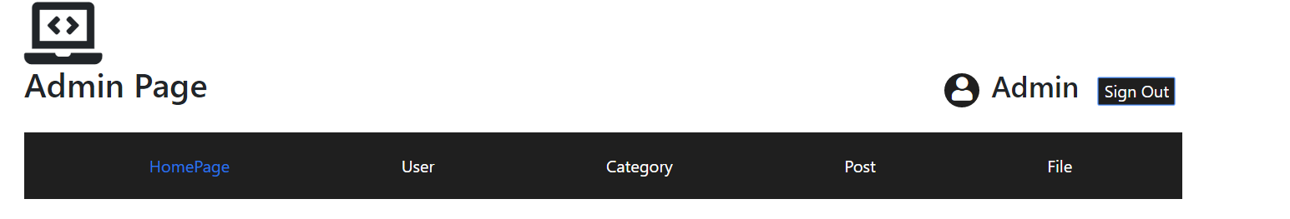Sign out button.
* Edit role
* Add role
* Add post
* Save as draft post
* Cancel post
* Edit post -> same die links
* Delete file
* Edit file

1. Home page does not show all possible pages for admin.
2. Bad UX.

* 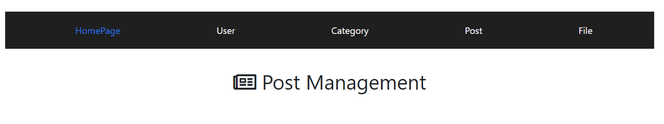Header does not change to blue when clicked.
* 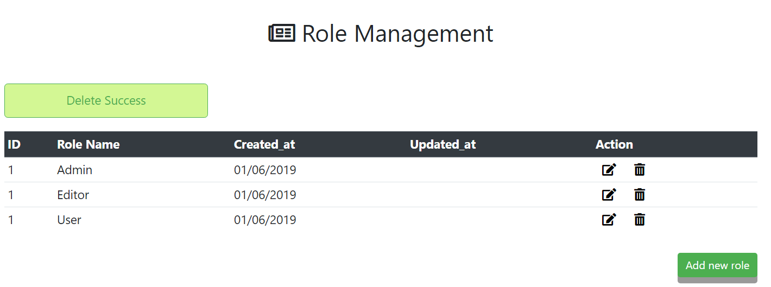All the alerts do not disappear after confirmation.
* Edit + Delete file placed not suitable place.

**USER MANAGEMENT:**

* Edit button -> Header: Add new user.
* Password shows normal text.

**POST MANAGEMENT**

**FILE MANGEMENT**

* Cannot view nested file.

1. Non-admin
2. Front-end
3. Familiarity

* Sign in is placed the same place with the categories
* 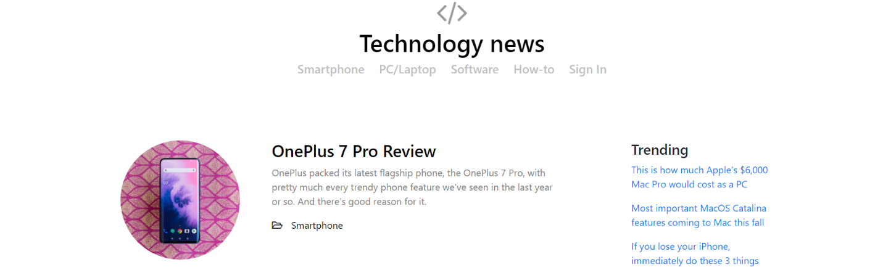No sign-up
* Using folder icon for category

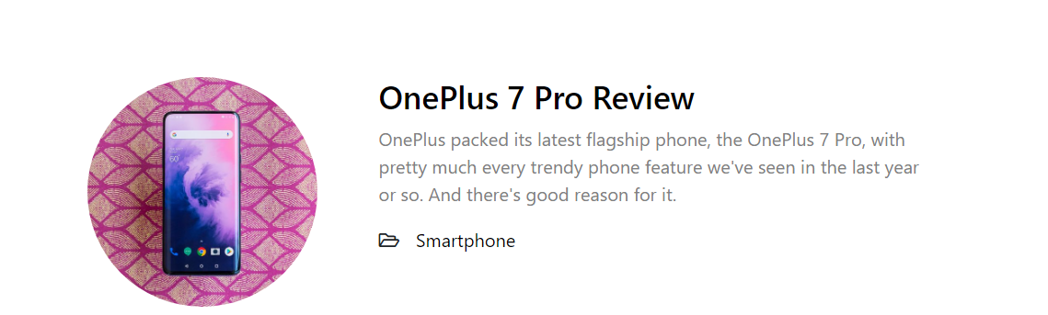

1. Substitutivity:

* 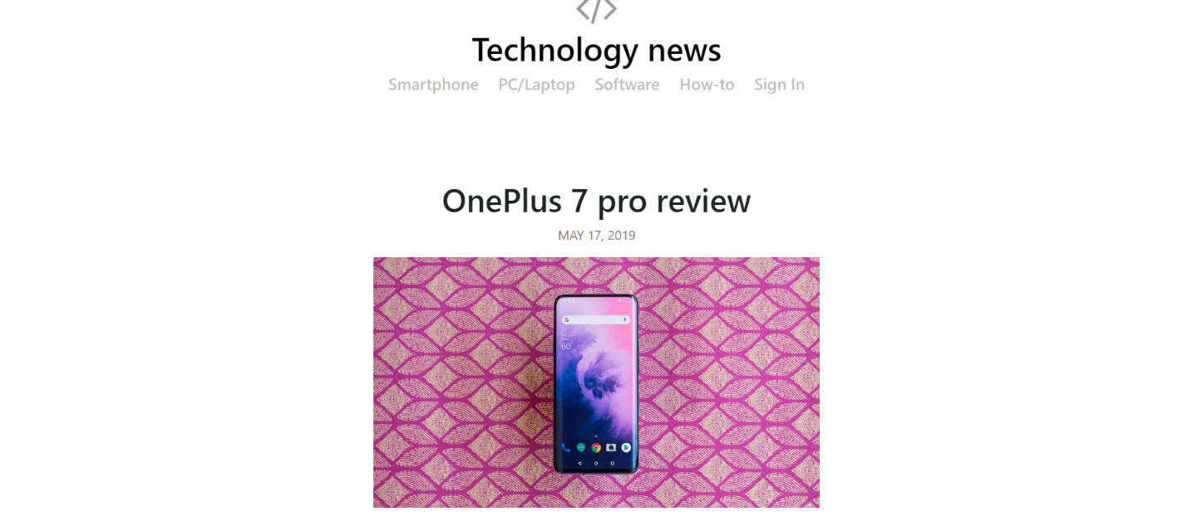No back button in any page
* 3 links for social networks not work:

